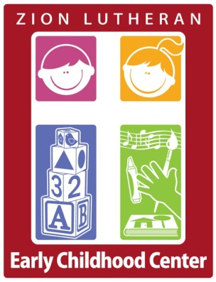

Tel 201-66408060

Fax 201-6647092

E staff@zionlutheanschool.org

64 First Avenue

Westwood, NJ 07675

www.zionlutheranschool.org

Celebrating 50 years

Dear Potential Donor:

It is with great excitement that we invite you to participate in a very special event:

Our Beefsteak Dinner and Auction on March 21, 2020.

Please consider supporting our event by donating gift certificates, merchandise or services. If you prefer, the committee will go shopping for you with a cash donation. All donors will receive excellent community exposure and advertising. Your company name and donation will be listed in the auction program. Your donation will directly benefit the education programs at Zion Lutheran Early Childhood Center, which are designed to help the child grow spiritually, emotionally, physically, and socially.

The item you donate could represent hundreds of dollars in auction funds raised. Please be sure to include any marketing collateral, brochures, and relevant details about the item so we can include an accurate description for potential bidders.

This auction is organized by volunteers from the school and church and it is the school’s largest fundraiser. Zion Lutheran is a 501(C)(3) entity; your donation is tax deductible to the extent allowed by law.

We thank you in advance for your support. All donations may be mailed to:

Zion Lutheran Early Childhood Center

Attn.: Auction Committee

64 First Avenue

Westwood, NJ 07675

\***Please mail donation by February 20, 2020.**

If you have any questions please feel free to call Mrs. Hector our school secretary at 201-664-8060.

Sincerely,

Zion Lutheran Early Childhood Center Auction Committee